 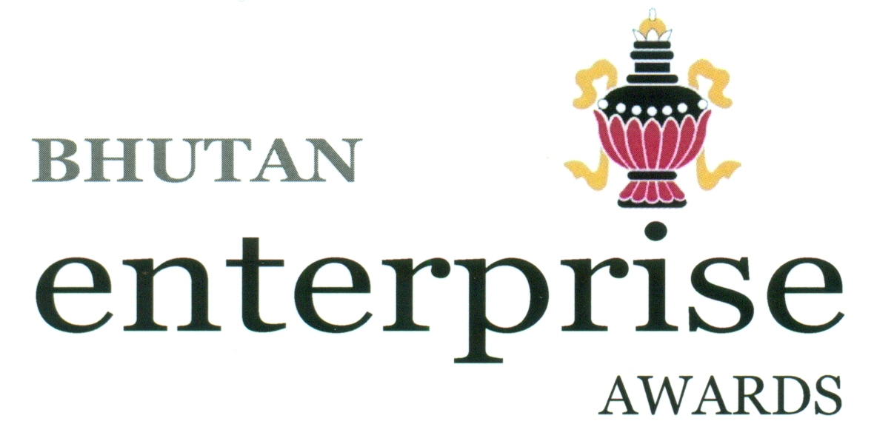

**Bhutan Enterprise Awards - 2019**

*~ call for application*

The Department of Cottage and Small Industry invites applications from cottage and small industries in Production & Manufacturing and service (IT enabled) sectors for Bhutan Enterprise Awards - 2019.

The best entrepreneurs for the year 2019 will be selected through competitive process and will be awarded a certificate along with cash prize in the following categories:

**Category & Prize**

* Small-Scale Entrepreneur of the Year: Nu. 200,000
* Cottage-Scale Entrepreneur of the Year: Nu. 200,000
* Woman Entrepreneur of the Year: Nu. 200,000
* Rural Entrepreneur of the Year: Nu. 200,000
* Service (IT enabled) Entrepreneur of the Year: Nu. 200,000

The last date for submission of application is **13th September 2019.**

The application form can be downloaded from ([www.moea.gov.bt](http://www.moea.gov.bt) or can be collected from the Regional Trade & Industry Offices /Economic Development Office in the Dzongkhags.

The Application Form along with supporting documents can be submitted to:



Department of Cottage & Small Industry,

Ministry of Economic Affairs,

Thimphu

or e-mail to *pd@gov.bt*

For any further information, please contact (02) 322406 or (02) 323506.